Sept. 22, 2016 PrintAhead 2.0

The next version of PrintAhead is going to further simplify operation and also enhance success rate. **My goal is that after the set-up screen is done, the work screen will open between 90-100% ready for print for those who do not do profile.**

**Revised Set-up process: ($200)**

**Attention: this point could be revised with the adaptation of an auto-find SDK**

In the revised Set-up we eliminate the tedious task of project name and folder. All project files will save in a Temp folder and will be overwritten by the next project. User won’t be able to save projects, only print (via 3D print/Color 3D print buttons).

Note: Pls. only comment out (but not remove) any of the HeadShop functionality from code, we will need it for HeadShop 11.

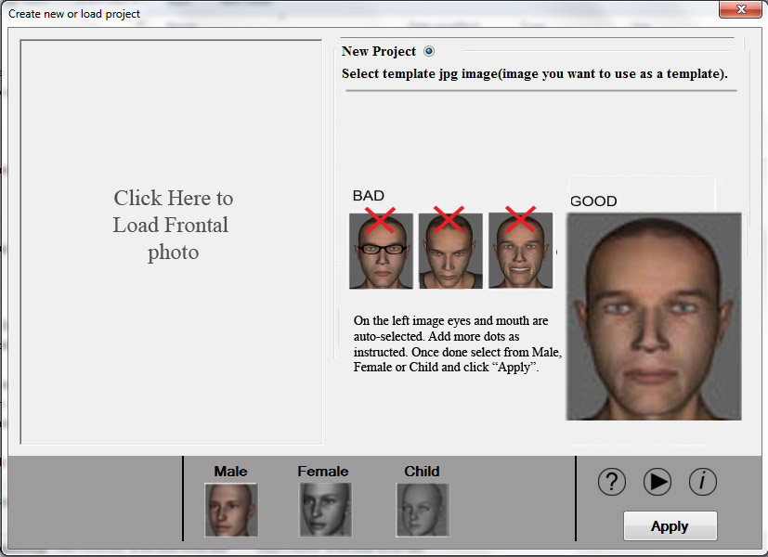

We will keep the auto-select (blue) dots for eyes and mouth. However, rather than moving the shape circles, we will ask user to follow the example on the right and place dots on the left where the flashing red dots indicate. (Need to talk about FaceSDK which is very expensive).

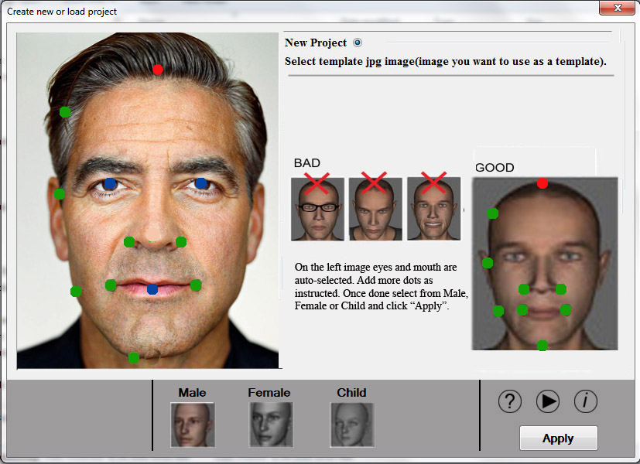

Next, when the work-screen opens up, the initial texture/shape mapping already applied to the right 3D head and Autodots are pressed and shown. The idea is that the head is 90% ready and there should be only minimal adjustment if needed. In addition, according to selection Male, Female or Child Neck/Pedestal also attaches on open.

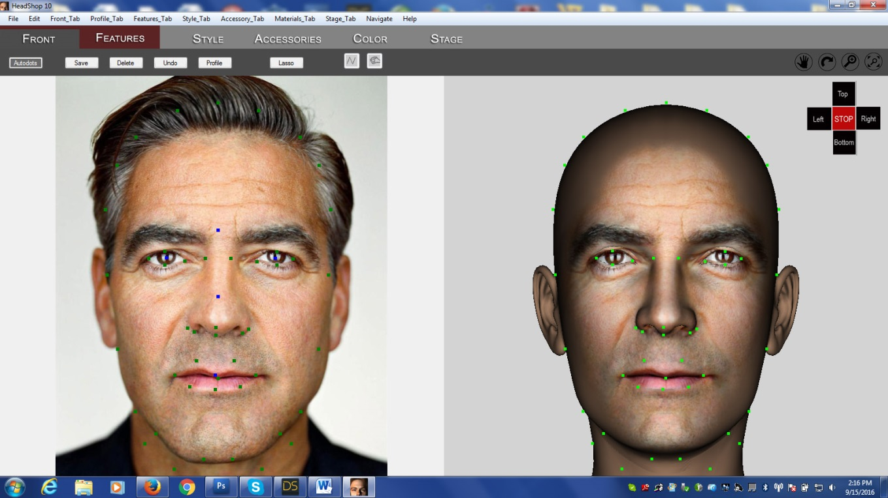

Rename “STAGE” to “PRINT”.

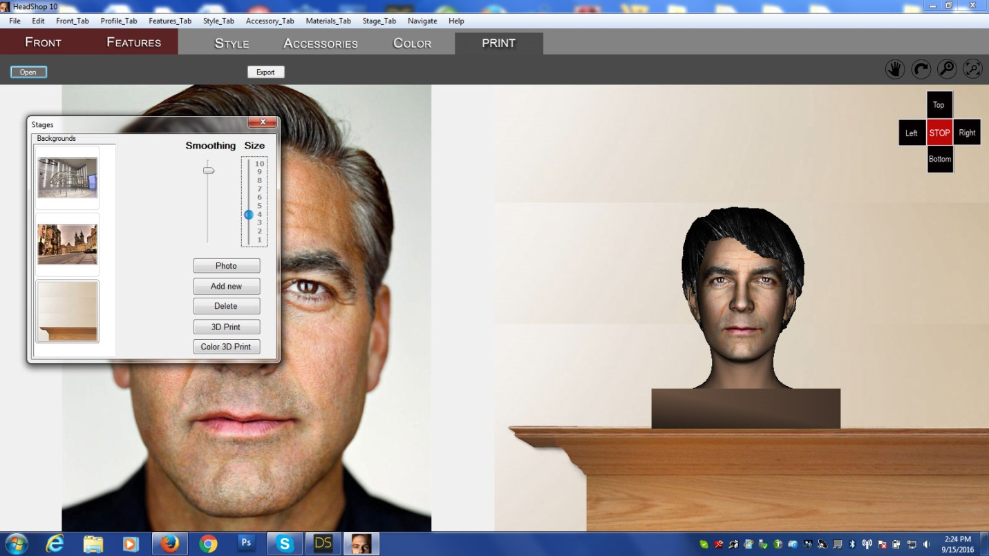

**Revised Print Process ($?)**

PrintAhead will be distributed in one version: PrintAhead 2.0: Fully functioning, except for the following:

1. No Export or Save of any kind (quoted out)
2. When Printing (color or b/w) heads, a $X dollar charge will apply to each print (each push of the print button). The interface will bring up PayPal and user has to pay $X before the print is allowed. (I should be allowed to adjust the price somewhere in the app).

This may require you to look into the PayPal API – not sure how this will affect how much work it will be for you. Please let’s discuss!

**Small Fixes ($100)**

1. As we have now combined shape and texture dots, sometimes the texture has edges, which show up in print. We need to do a better transition on the edges.

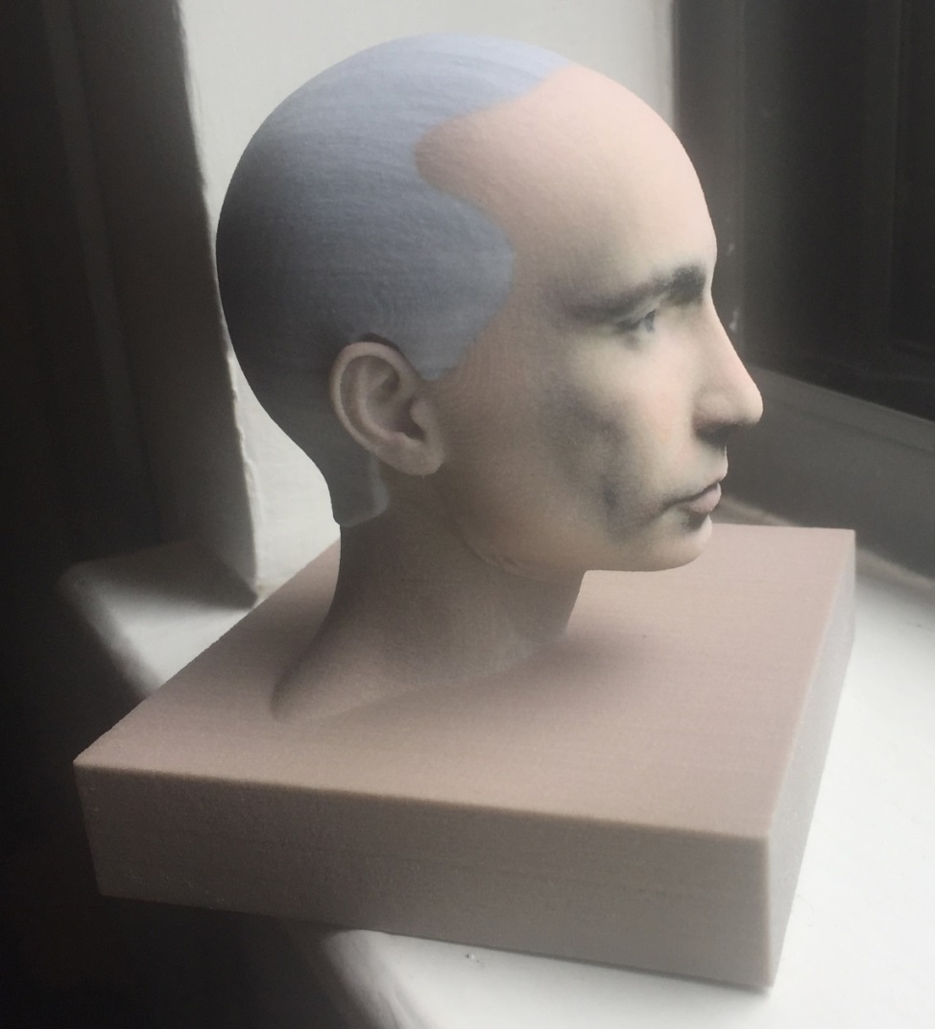

Current condition:

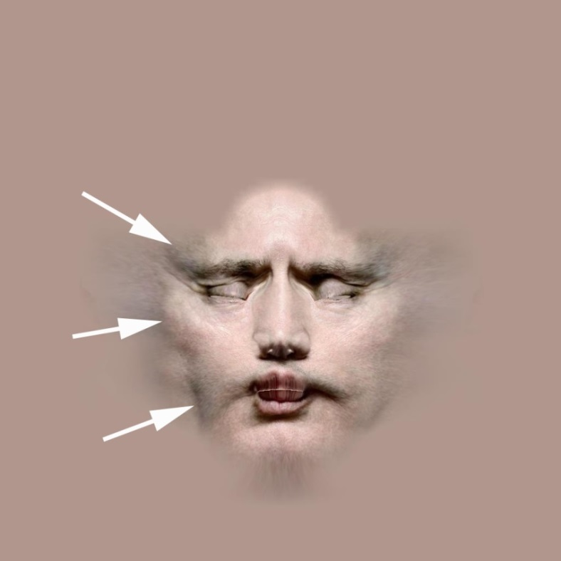

Desired condition:

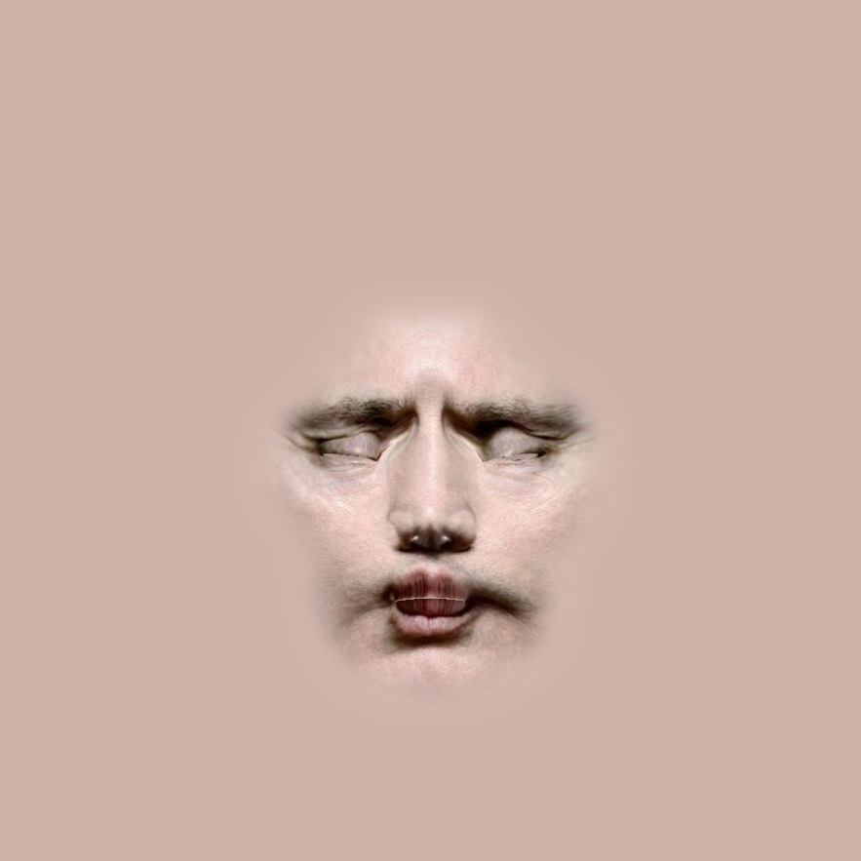

Another example:

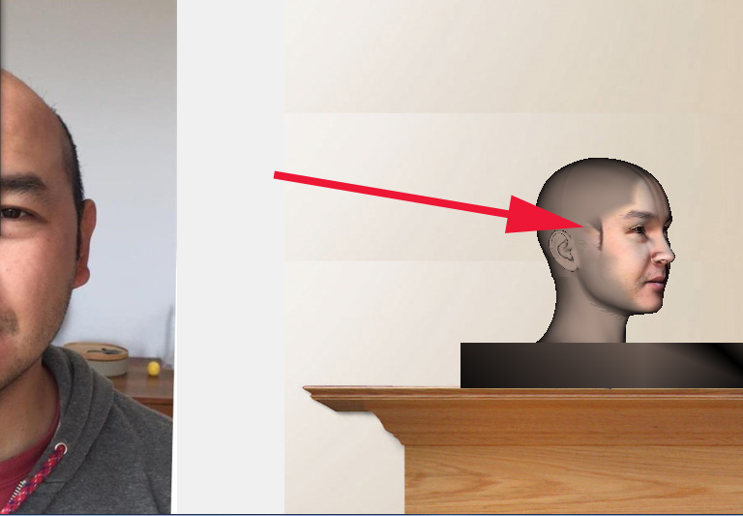

1. When user first selects an accessory and then a hair, accessory disappears.

Desired condition: should stay on

1. In Parts Library add 3 sliders as shown:

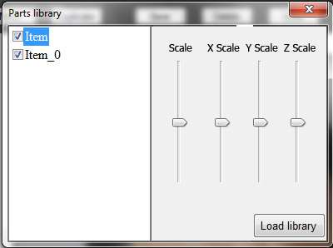

1. Default position of smoothen. After finished calculations, the default position of smoothen should be at 50% (looks better in results).

